**Smart Contract**

Code in Remix IDE using Solidity

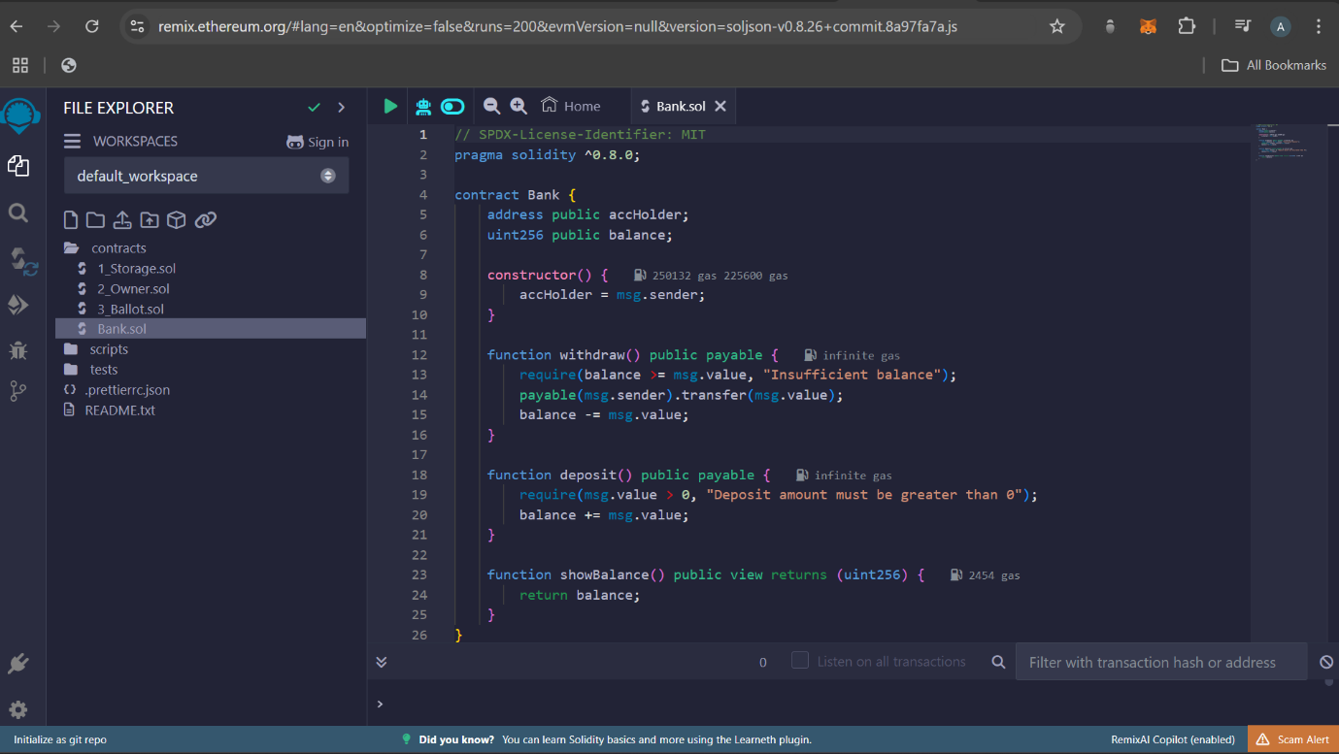

Click on compile (3rd symbol). Click on “Auto Compile”, if compilation is successful, it will show green tick

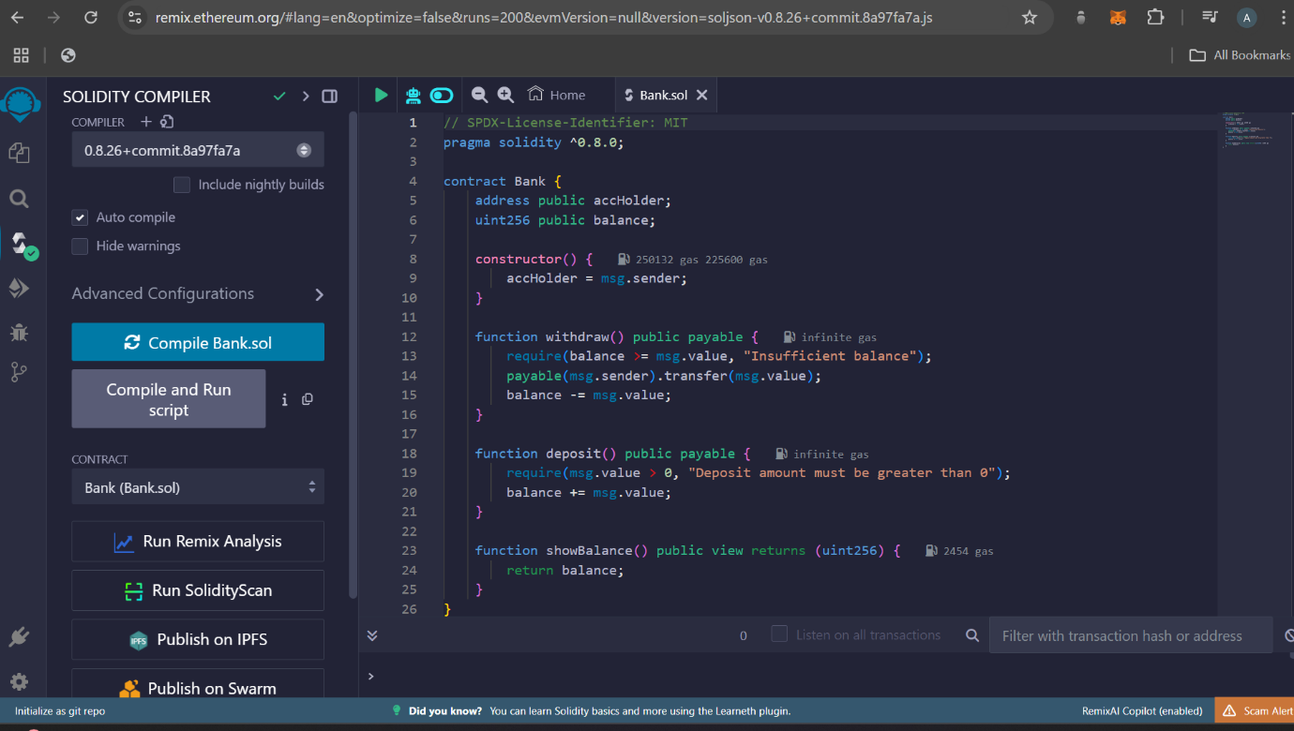

Click on deploy symbol (4th symbol) and then “deploy” button

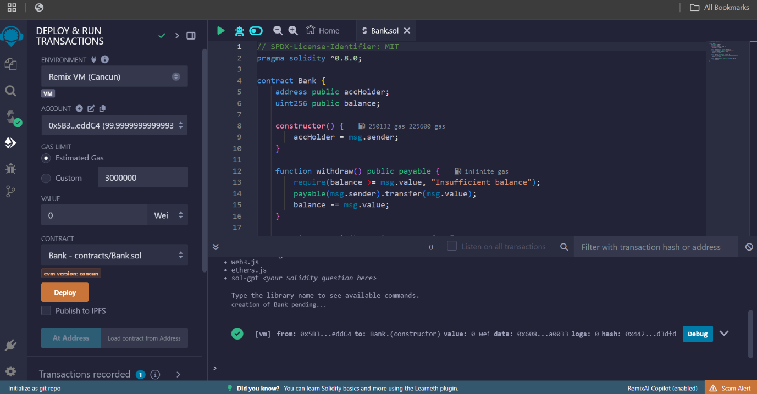

Scroll down and you can see functions, you can use it

